**Online Shopping Management System**

**PROJECT SUBMITTED TO SCHOOL OF SOFTWARE ENGINEERING, XIAN**

**XIDIAN UNIVERSITY, IN PARTIAL FULFILLMENT OF THE REQUIREMENTS FOR THE DEGREE OF BACHELOR OF SOFTWARE ENGINEERING**

**By**

**Class1 Team1**

**Under the Guidance of**

**ANGAJ SUNIL.M**



**XIDIAN UNIVERSITY**

**SCHOOL OF SOFTWARE ENGINEERING**

**GRADE-IV**

**XIAN**

**2013-2014**

**DECLARATION**

**We hereby declare that the dissertation entitled “Online Shopping Management System” submitted for the Degree of Bachelor of Software Engineering is our original work and the dissertation has not formed the basis for the award of any degree, diploma, associate ship, fellowship or similar other titles. It has not been submitted to any other University or Institution for the award of any degree or diploma.**

**Signature of the Project Manager**

**Place: Xidian University software school Name: Yang Xue**

**Date: Nov 7, 2013**

**Team List(31)**

|  |  |  |  |  |  |
| --- | --- | --- | --- | --- | --- |
| Student ID | Name | Signature | Student ID | Name | Signature |
| 13101111 | 陆融 |  | 13101152 | 吴天星 |  |
| 13101112 | 陈炯 |  | 13101154 | 孙晓晶 |  |
| 13101113 | 赵可琪 |  | 13101155 | 石梦瑶 |  |
| 13101114 | 邵佳翼 |  | 13101161 | 杨雪 |  |
| 13101115 | 章帅 |  | 13101163 | 刘心宇 |  |
| 13101116 | 崔楠 |  | 13101172 | 薛安逸 |  |
| 13101117 | 唐烨 |  | 13101175 | 陆宜达 |  |
| 13101127 | 陈福山 |  | 13101193 | 佟韬 |  |
| 13101129 | 潘畅 |  | 13101202 | 刘戈 |  |
| 13101131 | 孙思恒 |  | 13101206 | 田园 |  |
| 13101137 | 顾强 |  | 13101207 | 田一泓 |  |
| 13101143 | 程浩 |  | 13101211 | 刘梦宇 |  |
| 13101145 | 赵梓臣 |  | 13101214 | 谭碧莹 |  |
| 13101146 | 白冰 |  | 13101215 | 冯博博 |  |
| 13101148 | 陈俊昌 |  | 13101216 | 董芳钰 |  |
| 13101150 | 潘蕾 |  |  |  |  |

**CERTIFICATE**

**Certified that the dissertation “Online Shopping Management System” is a record of Project work done by Class1 Team1 Project Team during the period of their study under Angaj Sunil. M guidance, and that the dissertation has not previously formed the basis for the award of any degree, diploma, associate ship, fellowship or similar other titles and that it is an independent work done by them. Submitted for the Degree of Bachelor of Software Engineering is my original work and the dissertation has not formed the basis for the award of any degree, diploma, associate ship, fellowship or similar other titles. It has not been submitted to any other University or Institution for the award of any degree or diploma.**

**Signature of the Teacher**

**Place: Xidian University software school Name: Angaj Sunil**

**Date: Nov 7, 2013**

**ACKNOWLEDGEMENT**

**It is with real pleasure that, we record our indebtedness to our academic Guide, Mr. Angaj Sunil for his counsel and guidance during the preparation of this dissertation.**

**We are grateful to our guide and our School “School of Software Engineering, Xidian University” for kind cooperation and guidance through various stages of the project.**

**We wish to record our sincere thanks to our parents and all members of our team.**

**Our thanks are due to those who had helped me directly or indirectly in my project work.**

**Signature of the Project Manager**

**Place: Xidian University software school Name: Yang Xue**

**Date: Nov 7, 2013**

**Chapter Content Page No.**

1. List of Flowchart 10

2. List of DFD 13

3. Using Shopping Management System 16

4. Introduction: 29

5. Research Methodology 29

6. Advantages and Disadvantages 30

(i) Disadvantages over Old System

(ii) Advantages over Current System

Bibliography 53

**Flowchart No. Flowchart Title Page No.**

1.1. Tourist Module 10

1.2. User Module 11

1.3. Administrator Module 12

**DFD No. DFD Title Page No.**

2.1. Tourist Module 13

2.2. User Module 14

2.3. Administrator Module 15

**Screenshot No. Screenshot Title Page No.**

3.1. Tourist Module 16

3.2. User Module 20

3.3 Administrator Module 26

1. **List of Flowchart**
   1. **Tourist Module**

Start

Search

criteria

Is the good in Website?

Yes

Return good information

No

Return Error

End

* 1. **User Module**

Start

Good information

Function selection

Case1

Modify personal password

End

Log in

Add to the cart

Good information

Buy now

New address

Modify personal address

New password

Order management

Case2

Case3

Case4

Case5

**1.3 Administrator Module**

Start

New good information

Function selection

Case1

End

Log in

Add new product

Good information

Modify order status

Case2

Case3

Delete product

1. **List of DFD**
   1. **Tourist Module**

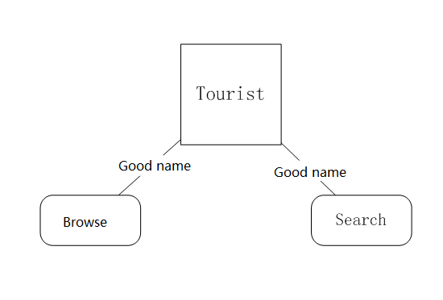

* 1. **User Module**

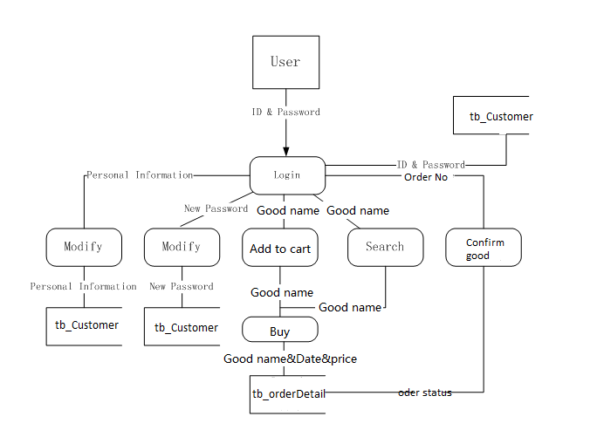

* 1. **Administrator Module**

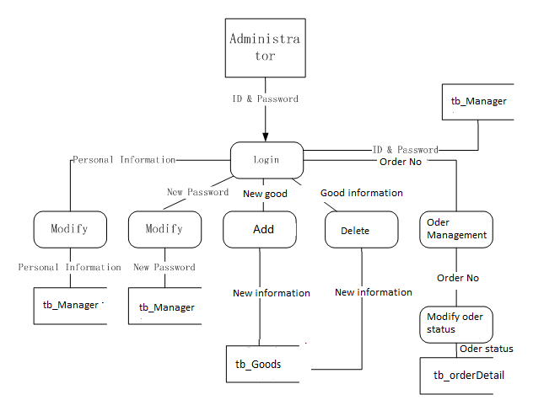

1. **Using Shopping Management System**
   1. **Tourist Module**
      1. **Module introduction**

The general visitor module provides the basic functions to the tourists of the Online Shopping Management System. Tourists don’t need to have an account to log in, they just need to open the foreground browser, and the browser must connect the database of the library.

The basic functions we provide are: Search information, register, and browse information.

1. For search function, a user can search the information about related goods using name of the goods or the type of the good or some related word about the good. And then click button to search.

2. For browse information, tourists can browse the type of the goods, and see the advertisement on the FrontPage, browse the details about the goods.

3**.** For register function, tourists can register to buy some goods, and input their information.

* + 1. **Function description**

● **Function1: Search**

Before this case start, the foreground browser must connect the database.

**Step1:**

1. Connect the foreground browser to the database.

**Step2:**

1. Input the keyword in the textbox. It is ok for full name or part of the goods’ name. For example, you can input the keywords "tv" into the search dialog.

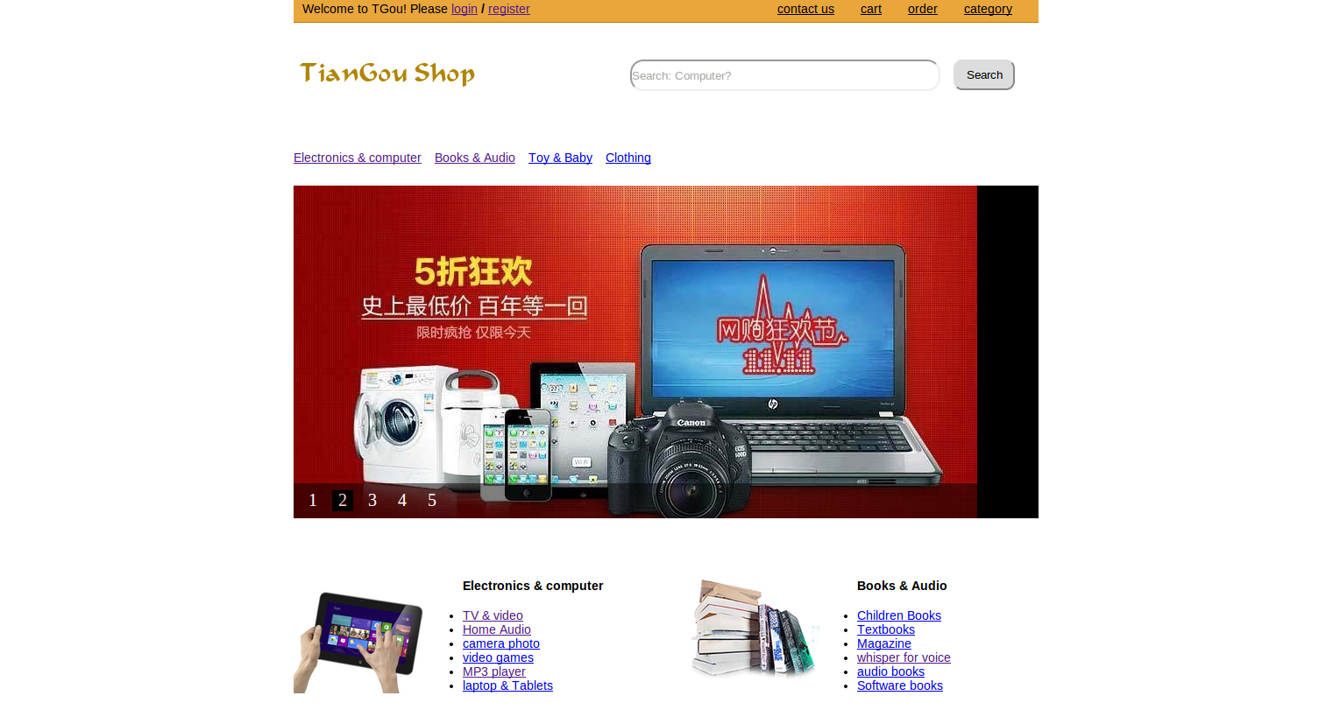

**Step3:**

1. Click the “search” button.
2. The foreground browser pushes the searching content to the database.
3. 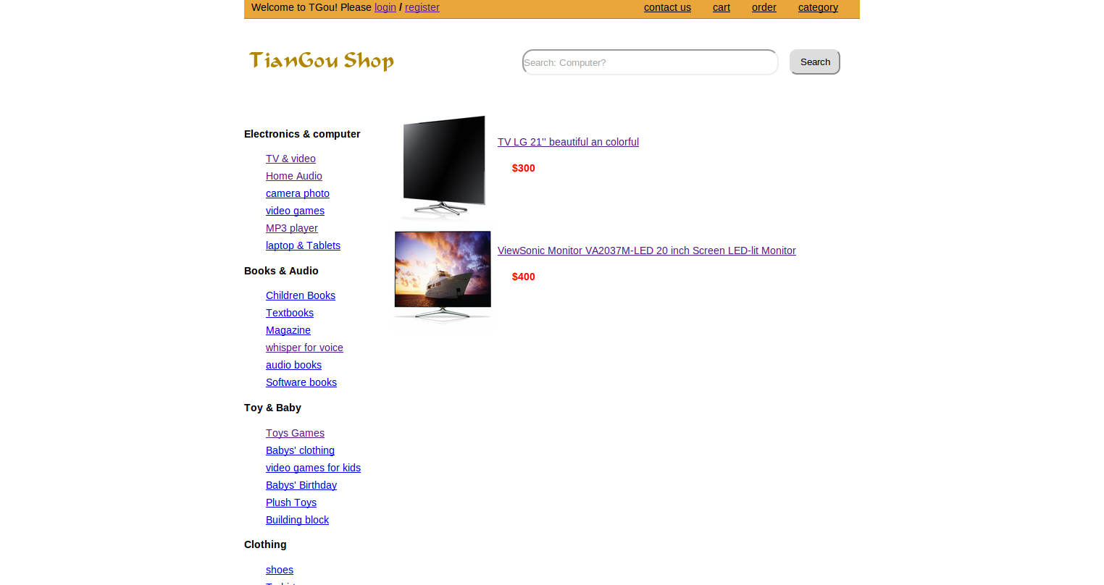Later on, the database returns the result of the item to the browser, and display. The content of displaying is the simple information of the good and the price of it.

**Step4:**

1. Click the good you want to buy.
2. The foreground browser pushes the searching content to the database.
3. Later on, the database returns the result of the item to the browser, and display. The content of displaying is the information of the good.

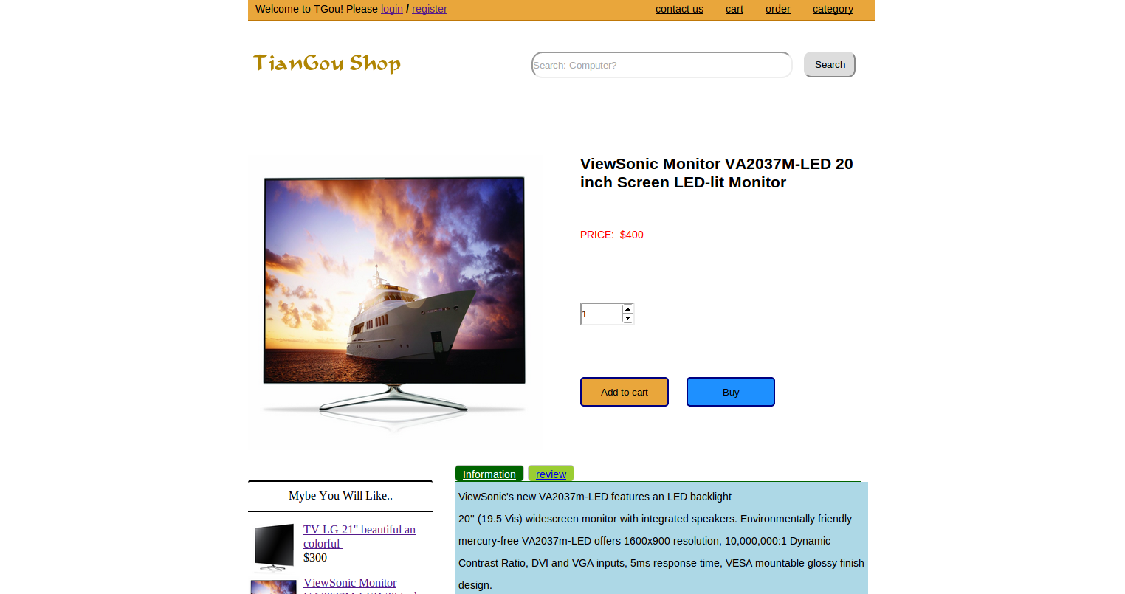

● **Function3: Register**

**Step1:**

1. 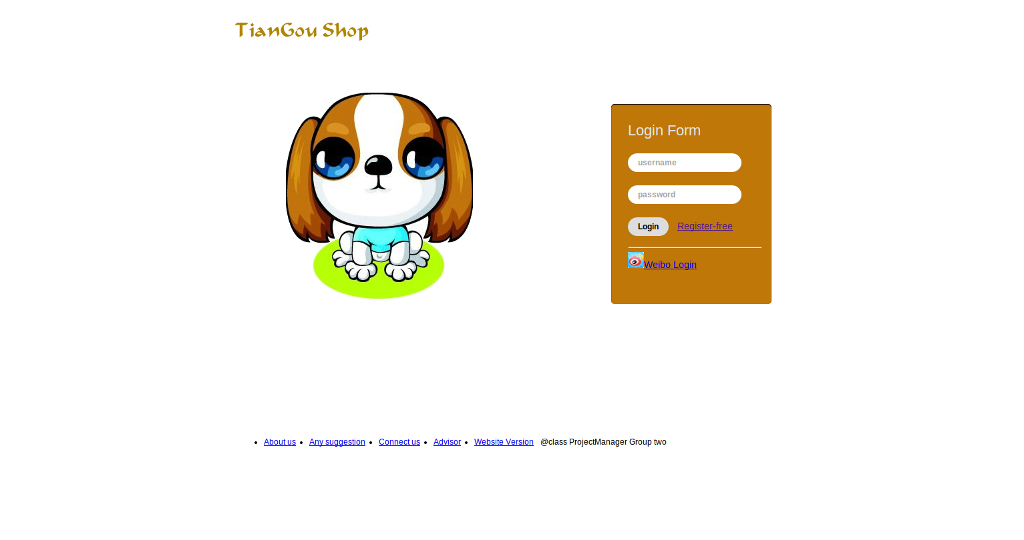 Click the register button or you click the buy button when you haven’t login and registered the pages will jump into the register page.

**Step2:**

1. 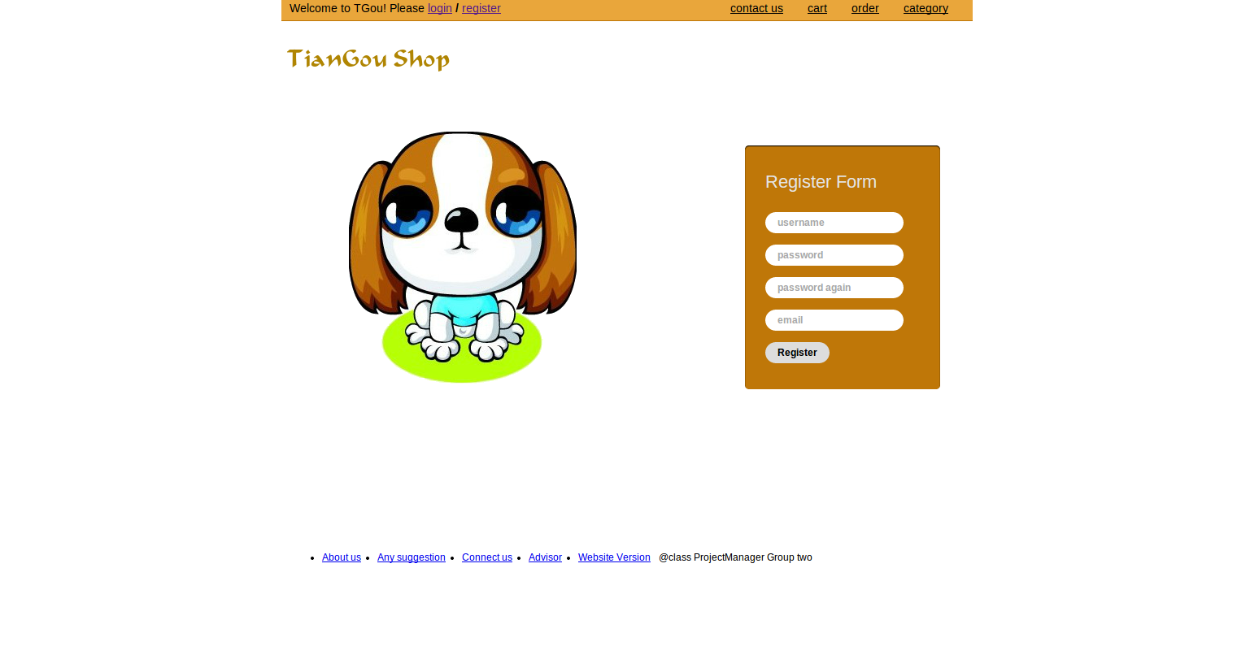 Input your username, e-mail, password and assure password again, then click the button.

## 3.2 User module

## 3.2.1 Module introduction:

The general user module provides the basic functions to the user of the Shopping Management system.

The basic functions we provide are: login, add to cart, buy goods, modify the address, cart management and order management. And the users have the same functions of tourist as browse and search.

## 3.2.2 Function Display

* **Function 1: Log in**

**Step 1:**

You can click the ‘log in’ button. Then the system will jump into the log-in page.

**Step 2:**

If you fill in the proper ID and Password, you can log in the system.

Otherwise, you cannot log in the system.

* **Function 2: Add good to cart**

**Step 1:**

Log in the system (Function1).

**Step 2:**

Find the good you want (Function 1 of Tourist).

**Step 3:**

If you want to add the good to cart, you can click the “Add to cart” button then the good can be added to the cart. If this kind of goods has sold out or the number of the good you select as zero, the system will send you a box to inform you that your behavior is failed.

* **Function 3: Buy**

**Step 1:**

Log in the system (Function1).

**Step 2:**

Find the good you want (Function 1 of Tourist).

**Step 3:**

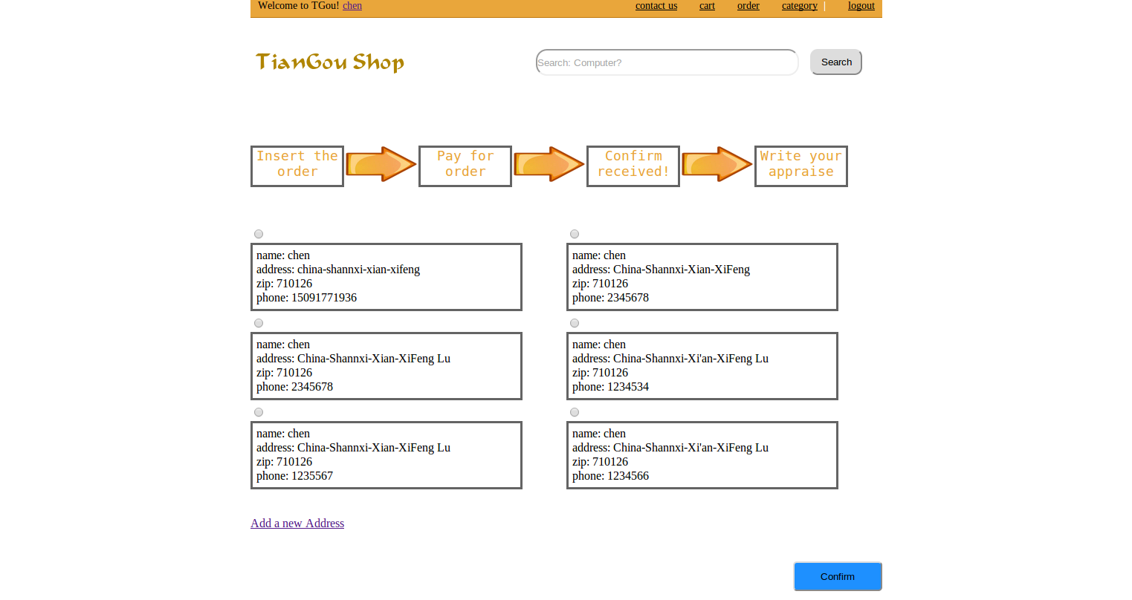 Select the number of how many goods you want to buy and click the “Buy” button. Or pay for the order in cart. You can jump to the pages to select your address:

**Step 4:**

If you want add new address, you can click the “Add a new Address” button at the left bottom of the pages and input your new address and click the “Add” button.

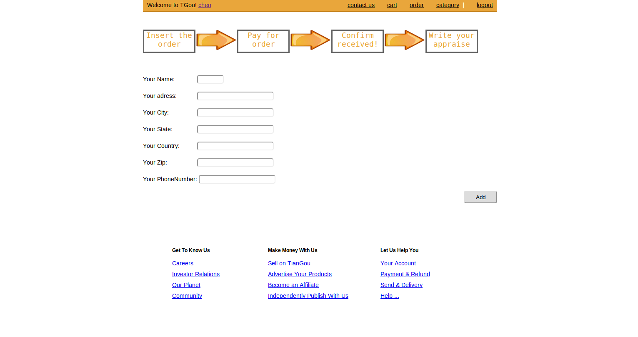**Step 5:**

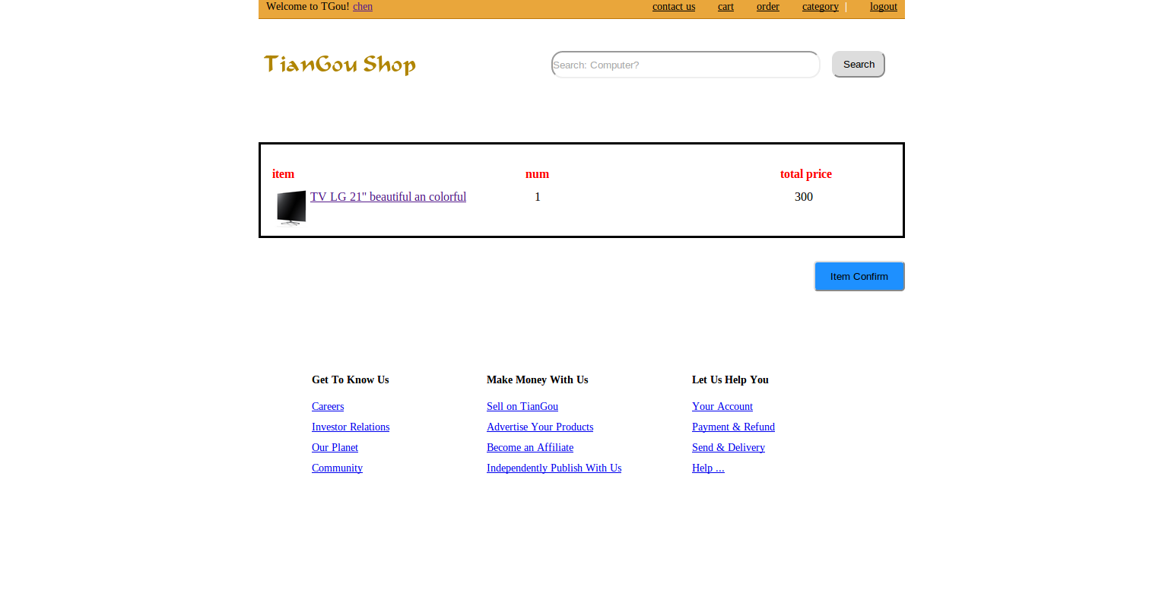Click the ‘Confirm’ button at the bottom of this page, you’ll jump into a page to confirm your order. If you have confirmed the order then click ”Item Confirm Confirm” button.

**Step 6:**

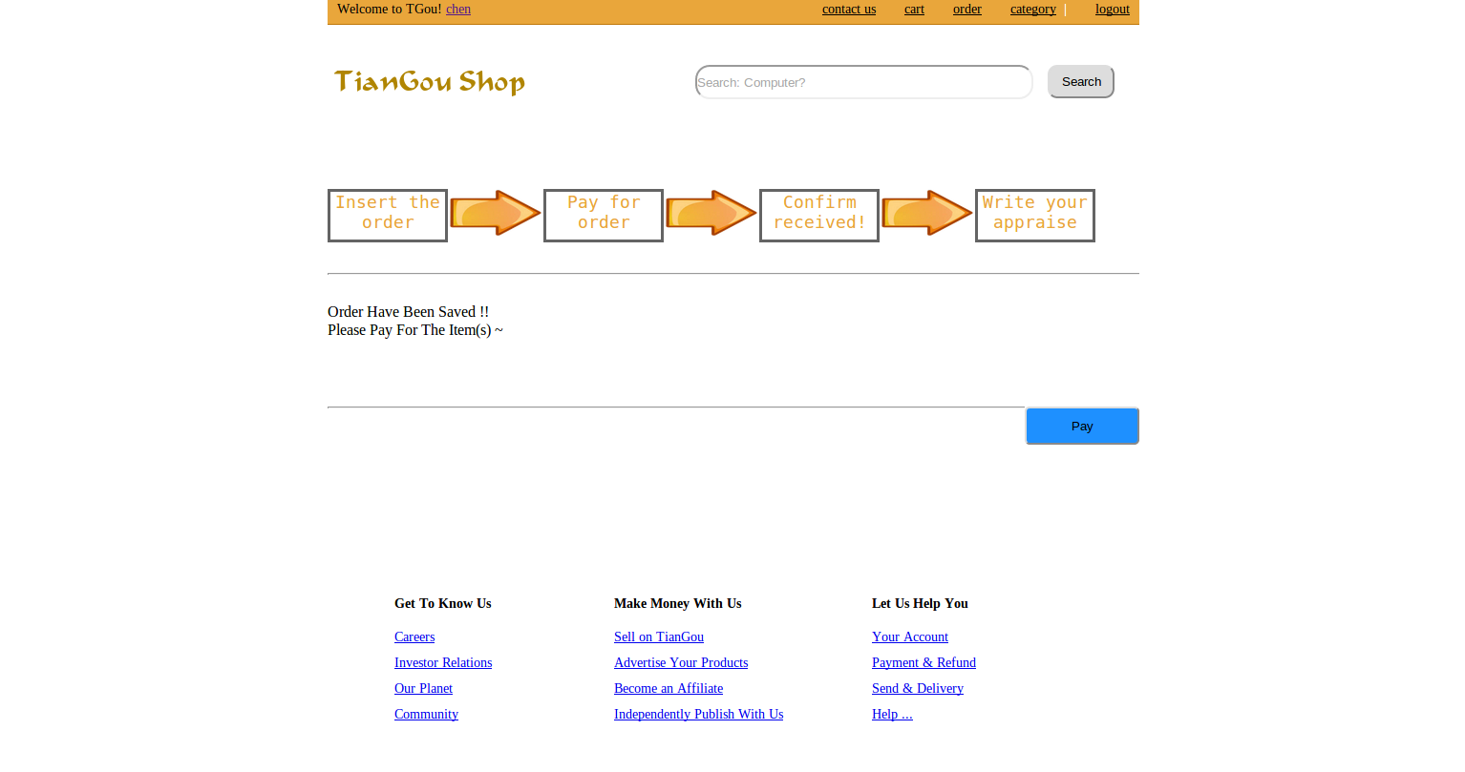Click the ‘Pay’ button at the bottom of this page, you can pay for the order.

* **Function 4: Order Management**

**Step 1:**

Log in the system (Function 1).

**Step2:**

Click on “Order” and then the page will shown as follows. The user can choose to receive the goods which have been delivered. Other orders user only can check them.

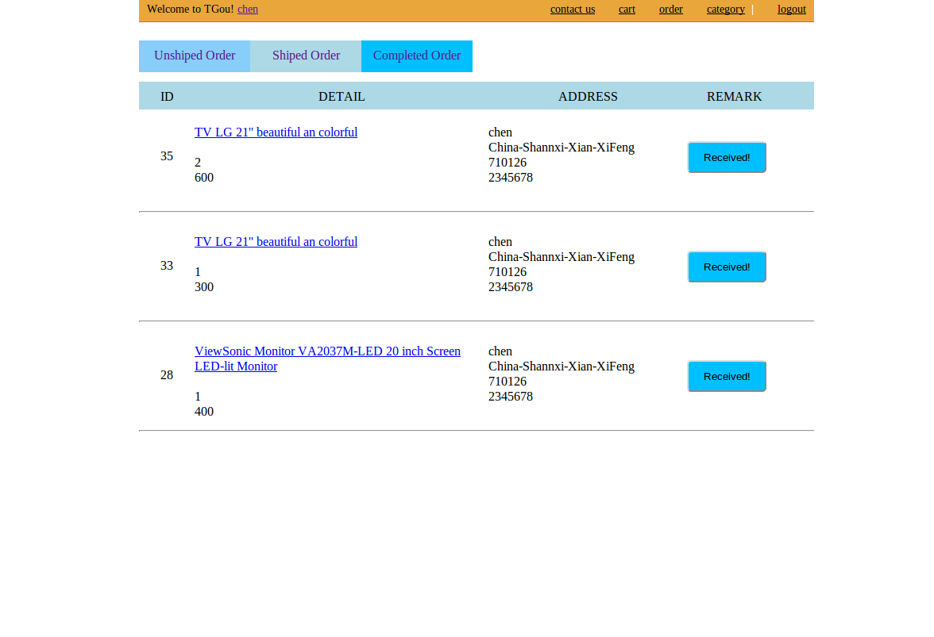

**Step3:**

If you receive the good you have buy, then click the button to confirm received.

* **Function 5: Comment**

After you confirm received in function 4, you can input your comments about the goods, the comments will be inserted into database and showed in the pages as information about the goods.

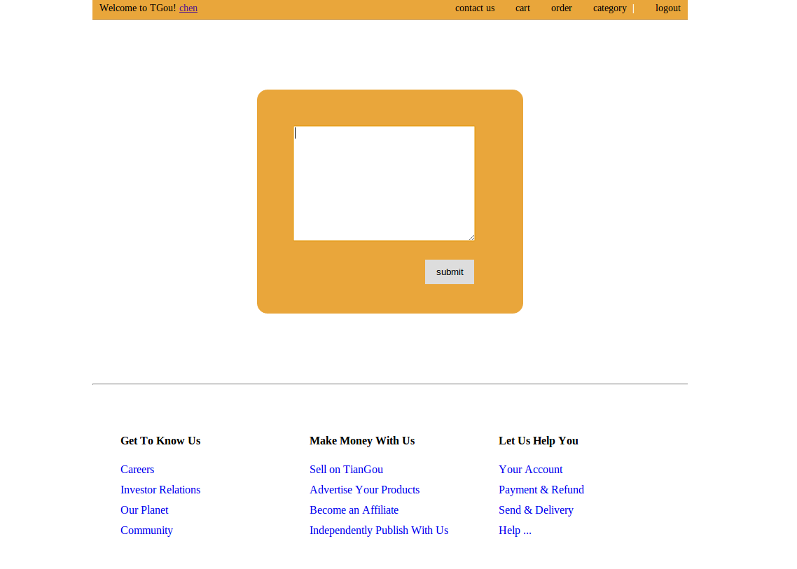

After you have commented, you finished once shopping, you will jump to a thank page.

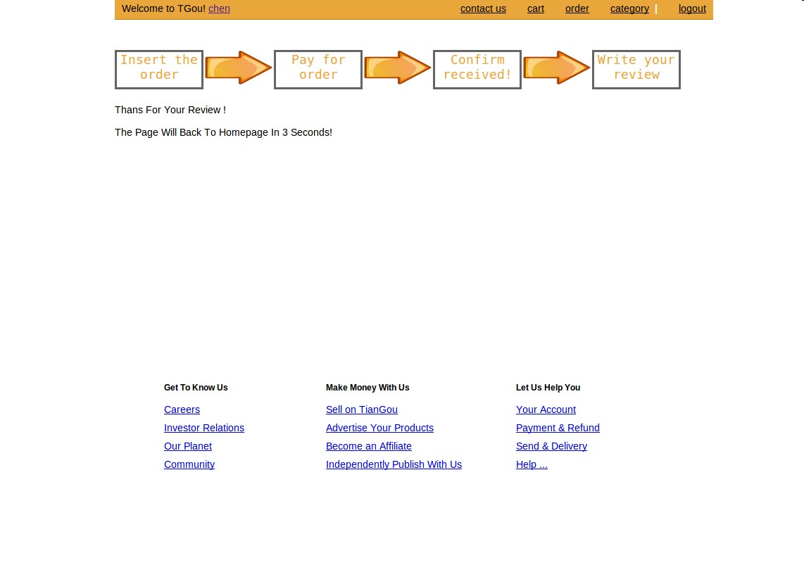

* **Function 6: Cart Management**

**Step 1:**

Log in the system (Function 1).

**Step2:**

Click “Cart” button and then the page will shown as follows:

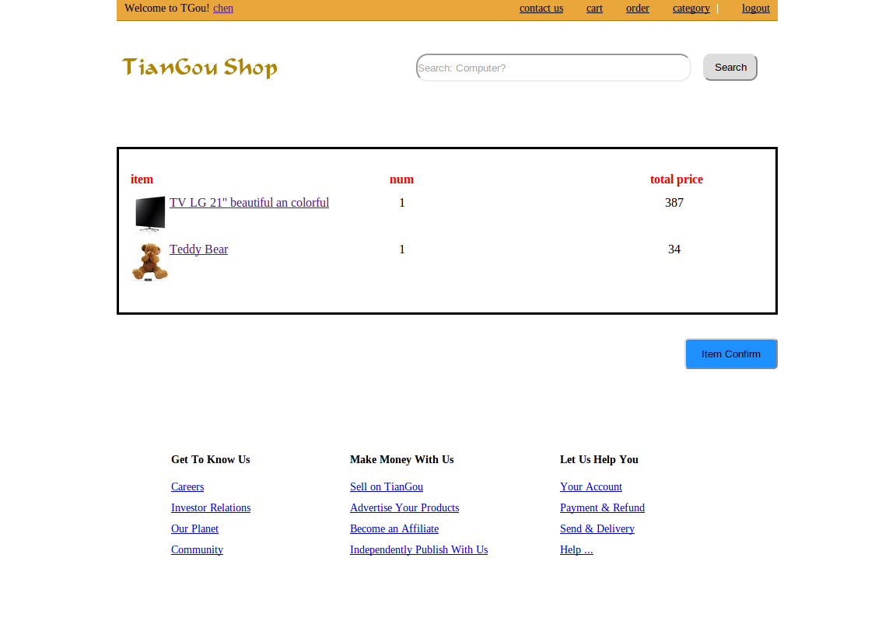

**Step3:**

Click “Confirm the Item” button to buy it, the following steps are the same as function 3

* **Function 7: Modify users password**

Click on your user name to the personal pages about yourself, you can change the information about your password. You have to input your old password and confirm your new password, and then the password set successfully.

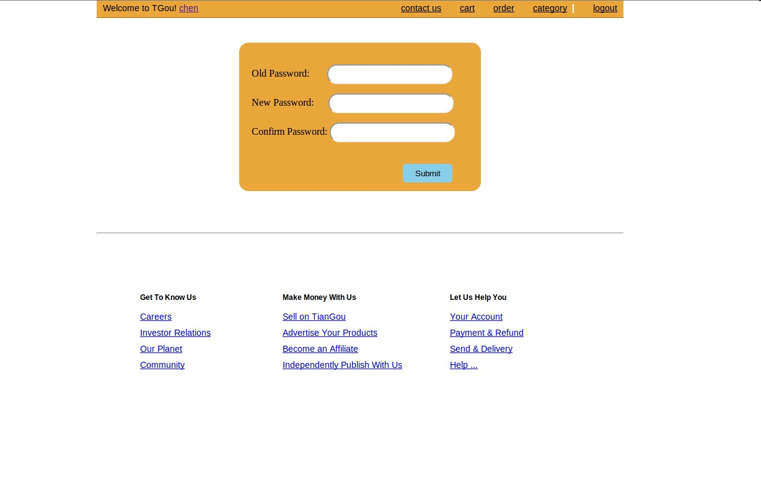

**3.3 Administrator Module**

**3.3.1 Module Introduction:**

## 1) Description:

This function can only be used by the administrators of the online shopping management system.

## 2) Function display:

## Administrators login the system only when they input the correct ID(id number) and PW(password).

## After successfully registered, the page will direct to the page: “<http://localhost/shopping/admin.php>”

## D:\360data\重要数据\我的文档\Tencent Files\1296875661\FileRecv\admin-homepage.png

**3.3.2 Function descriptions**

## ● Function 1 : Add Items

Click on the button “Add Items”, then we will go to the page “<http://localhost/shopping/additem.php>”.We should fill in both the item name and the price, we select the type and pictures of the added goods , then we click on the “Add” button. Then the servers will updates the information in the database after submits.

## D:\360data\重要数据\我的文档\Tencent Files\1296875661\FileRecv\add-item.png● Function 2 : View Order

When we click on the button “View Order”, in this page we can see the orders also the different status about the orders. This page shows Unshipped Orders.

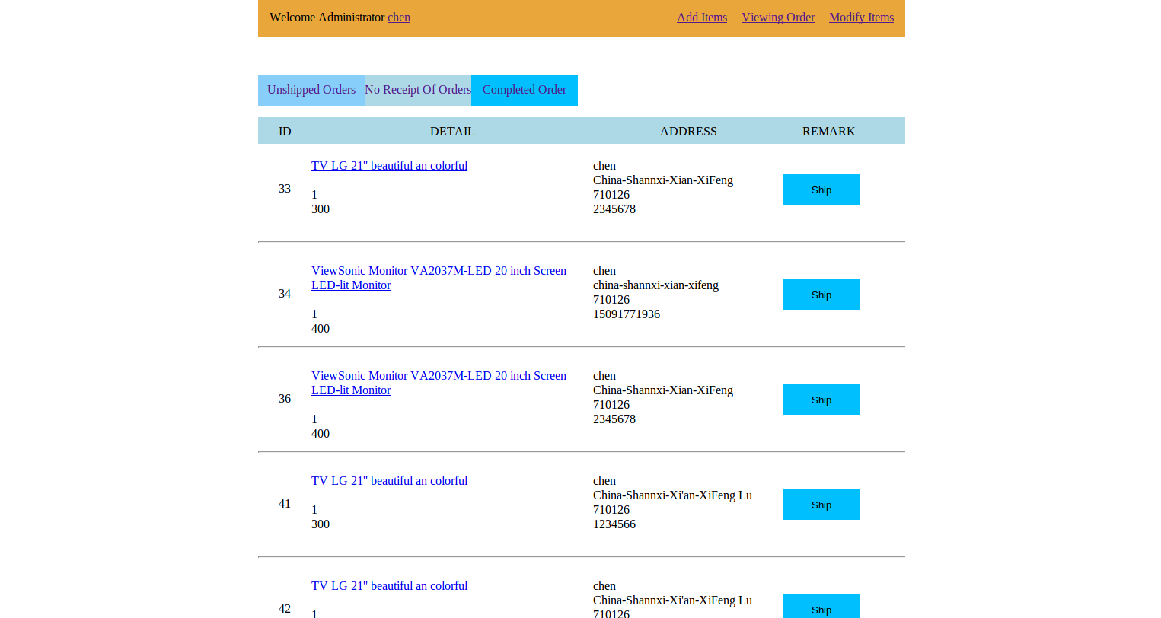

Orders have been shipped:

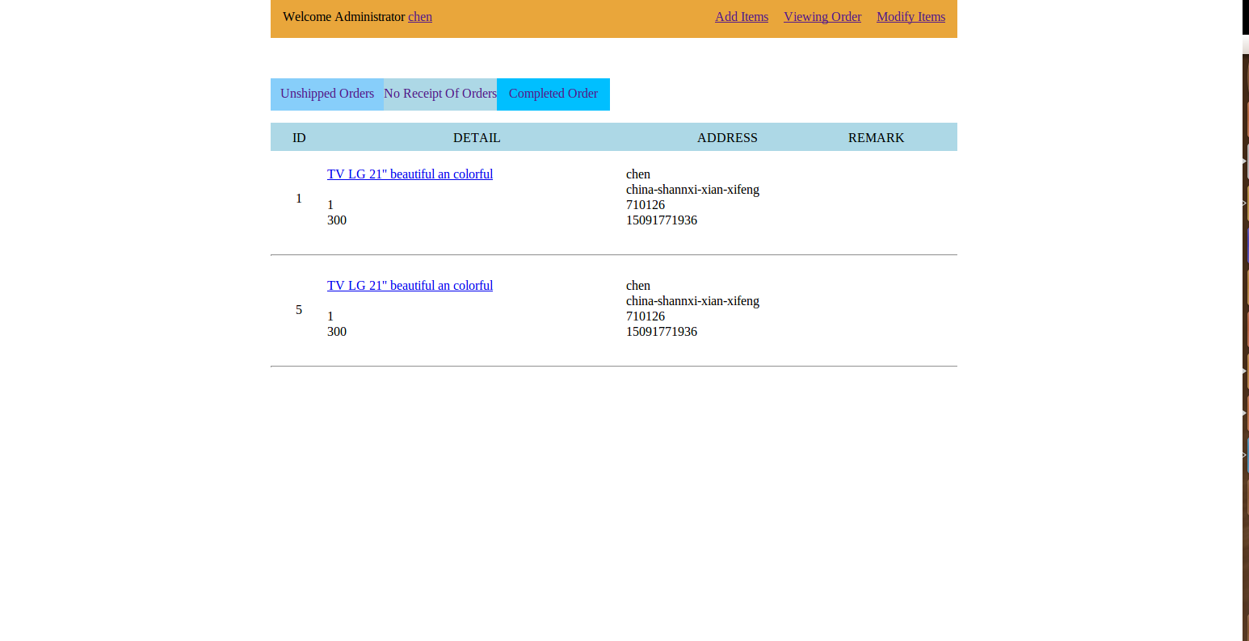

Completed Orders:



●  **Function 3 : Deliver Goods**

**Step1:**

When we click on the “Unshipped Orders” we will go to page

“<http://localhost/shopping/unshiporder.php>” (Function2 of Administrator).

**Step2:**

Click “Ship” button when we can deliver the goods and the users can see the status about it. And the good will decrease in the database.

**Step3:**

Select which company to send the goods. Then you will get a tracking number, which the customer can follow it.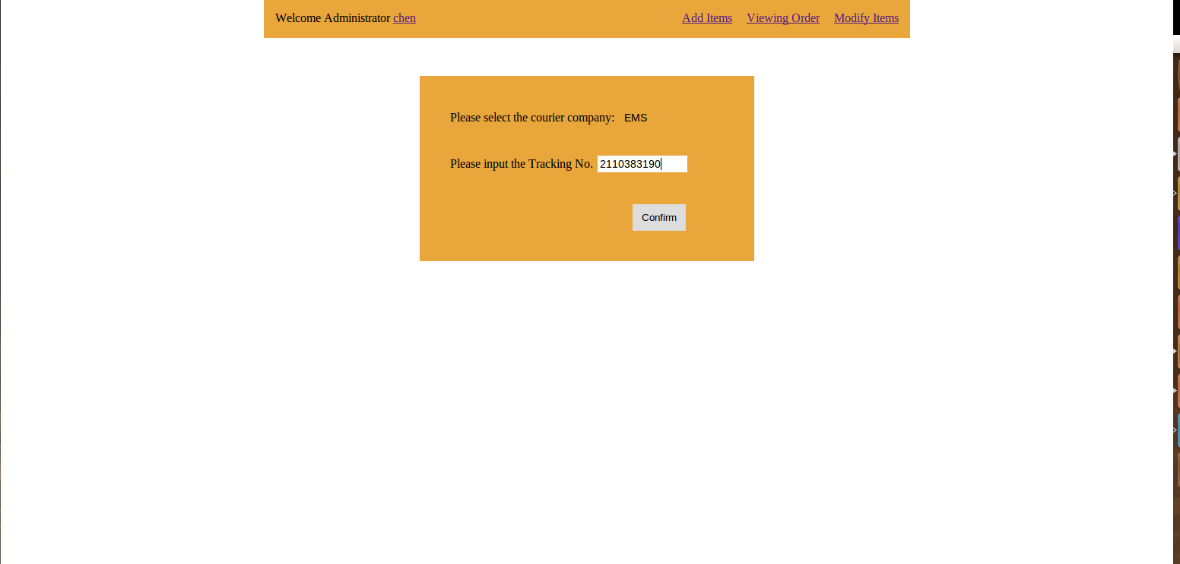

## ● Function 4 : Modify Items

When you click the “Modify Items”, and you can modify the information about the items such as price and delete them. After you click the submit button, the server will detect the form, full to submit. Then the server updates the information in the database after submit form.

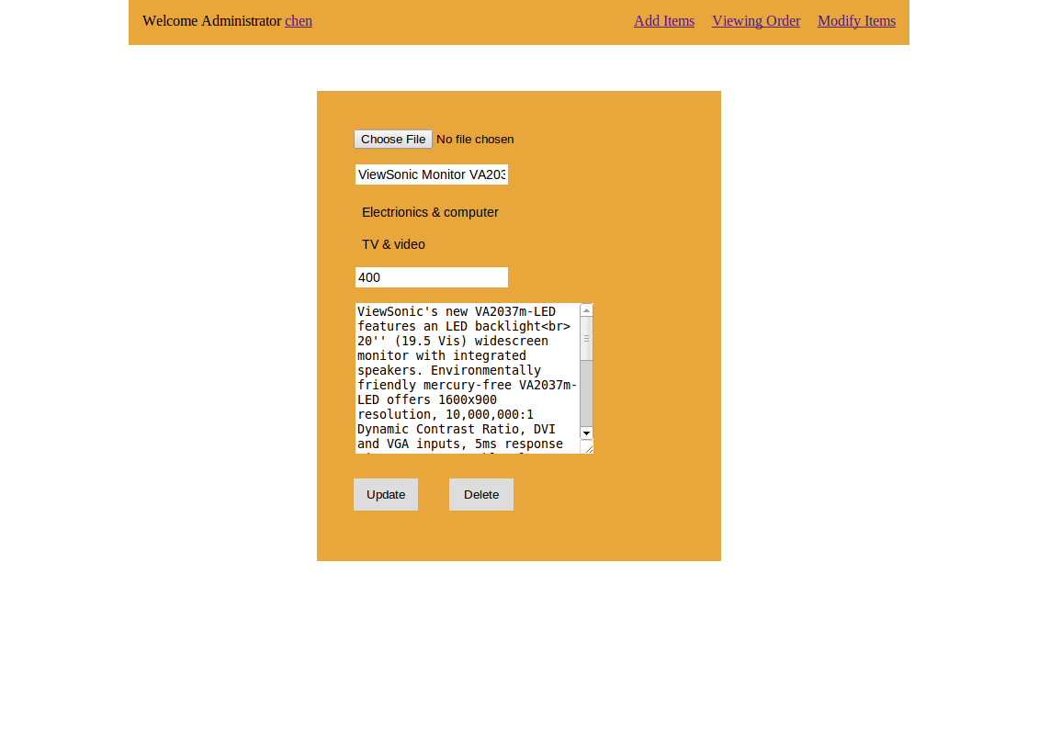

1. **Introduction**
   1. **Statement of Problem**
2. Despite the fact that the current running system is able to almost satisfy the main demands of our work with respect to the shopping management, there exist amounts of unavoidable flaws.
3. We have to install the relevant program on each computer, and the proceeding of installation is relatively complicated, which calls for engineers with computer expertise, thus in case of emergency when the computers break down, the work cannot be carried out until all the staff for maintenance are in the right place timely.
4. For the system at present, when the managers do not in their turn, they are avoided to operate the system or handle the transactions, and sometimes the managers should operate the system in outside web.
   1. **Objectives of the Study**

We want to develop an online shopping management system which is based on B/S model. We aimed at working out a web application which helps for convenient shopping. All operations will be shortcut and safe.

1. **Research Methodology**

**OS**: windows 7 Ultimate

**Programming Language**: JavaScript,html5, php Version 5.3.10-1

**Develop Tools**: photoshop CS5,mysql 5.5, sublime text2 version 2.2 ,apache

**Server App**: apache

**Database**: mysql 5.5

**Test Tools:** Chrome

**Browser:** IE/ Chrome

With php (Version 5.3.10-1), html5, JavaScript and Database MySql, We developed this Online Shopping Management System. The system is B/S structure. MVC pattern enhanced the quality of our system. Let nature take its course, we user php to present our information to our users. And JavaScript make it more beautiful. These technologies have done a good job.

**Why MySQL ?**

As the world's most popular open source database, MySQL has a lot of advantages:

1) MySQL is free under their community licensing.

MySQL was also recently acquired by Sun, as such you can expect more 'pre-baked' functionality in Java in the future.We can use c #or VB.NET to write SQL CLR (Common Language Runtime) which includes SQL Procedure.

2) It can be easily used:

Like oracle, MySQL also has powerful functions. MySQL is open source (so free), robust and fast. It is also easy to install on pretty much any operating system.

It provides most of the features that a database like Oracle those.

As we are building a small to medium application it will most likely suit our needs.

**6. Advantages and Disadvantages**

**(1) Disadvantages over Old System**

The old one has many problems when we use it.

* It makes more burden for the clients' computers, for it needs a specific client to be installed on the users' computer.
* It requires the operators or administrators to be more skilled in computer,which increases training expenses.
* It runs slowly, so it took us much more time to operate.

**(2) Advantages over Current System**

* Certainly, the new system change the situation.
* It costs less expenses，we will not need a client on each user's computer, administrators do not need to be trained to operate the system.
* It runs faster and can be used by more people at the same time. As long as the network is fine and the server works well, any reader can access the system.
* It is safer. All the information is stored in the server not in the users' computers.
* It is more easy for administrators to manage much too many goods.
* It is much more user-friendly. Users will find it easy to use.

**Bibliography**

<<数据库系统概念>>

<<项目管理>>